PRACTICAL FILE

OF

DATABASE MANAGEMENT SYSTEM

**InDEX**

|  |  |  |
| --- | --- | --- |
| **S.No.** | **Topic** | **Page No.** |
| 1. | Introduction to DBMS and MS Access | 1-2 |
| 2. | Role of DBMS in Social Media Site | 3 |
| 3. | Introduction to project and schema | 4-5 |
| 4. | Tables and their relationships | 6-15 |
| 5. | Query | 15-18 |
| 6. | Reports | 19-20 |
| 7. | Forms | 20-21 |

**DATABASE MANAGEMENT SYSTEM**

Database is a collection of inter-related data which helps in efficient retrieval, insertion and deletion of data from database and organizes the data in the form of tables, views, schemas, reports etc. For example, university database organizes the data about students, faculty, and admin staff etc., which helps in efficient retrieval, insertion and deletion of data from it.

The software which is used to manage database is called Database Management System (DBMS). For Example, MySQL, Oracle etc. are popular commercial DBMS used in different applications. DBMS allows users the following tasks:

* **Data Definition**: It helps in creation, modification and removal of definitions that define the organization of data in database.
* **Data Updation**: It helps in insertion, modification and deletion of the actual data in the database.
* **Data Retrieval**: It helps in retrieval of data from the database which can be used by applications for various purposes.
* **User Administration**: It helps in registering and monitoring users, enforcing data security, monitoring performance, maintaining data integrity, dealing with concurrency control and recovering information corrupted by unexpected failure.

*Now let’s have an introduction about the MS Access which is a software application used to develop a Database Management System.*

**MS ACCESS**

Microsoft Access is a Database Management System (DBMS) from Microsoft that combines the relational Microsoft Jet Database Engine with a Graphical User Interface (GUI) and Software Development tools. It is a part of the Microsoft Office suite of applications, included in the professional and higher editions.

Microsoft Access stores information which is called a database.

To use MS Access, you will need to follow these four steps −

* **Database Creation** − Create your Microsoft Access database and specify what kind of data you will be storing.
* **Data Input** − After your database is created, the data of every business day can be entered into the Access database.
* **Query** − This is a fancy term to basically describe the process of retrieving information from the database.
* **Report (optional)** − Information from the database is organized in a nice presentation that can be printed in an Access Report.

*Now we shall learn more about this with the help of the project on ‘SOCIAL MEDIA SITE’.*

**SOCIAL MEDIA SITE AND DATABASE SYSTEM**

A social media site is an online platform which people use to build social networks or social relationship with other people who share similar personal or career interests, activities, backgrounds or real-life connections. Social media sites allow users to share ideas, digital photos and videos, posts, and to inform others about online or real-world activities and events with people in their network.

A social media site database must be very much strong enough to hold the information about all the users in a greater detail and it should also provide the security features to the users so that the data shared by them is not used wrongly by anyone. The database of the social media site must be scalable i.e., with the growing number of users it must be able to accommodate the growing amount of data. The database must also have the ability to backup and ensure the recovery of the information stored within.

The database of the social media site must be effective and easier to operate. It should contain the information in a systematic manner for all the posts, images, advertisements, videos, etc., that are being shared among the users. It maintains the information about the users, their friends, their basic profiles, posts, messages, stories, chats, etc., with updation at each moment the user logs in to the site.

**INTRODUCTION TO PROJECT**

A relational model is the one which stores data in the form of tables. A relational model database is defined as a database that allows one to group its data items into one or more independent tables that can be related to one another by using fields common to each related table.

Therefore, the tables included in the SOCIAL MEDIA SITE DATABASE are as follows:-

* User
* Contact
* Device
* Access
* Conversation
* Deleted Conversation
* Message
* Deleted Message
* Participant
* Reports
* Block List

The plan or scheme of the database is known as the Schema. Schema gives the names of the entities and attributes. It is the framework into which the values of data items (or fields) are fitted. It includes the definition of the database name, record type and the components that make up those records.

Therefore, the schema for the SOCIAL MEDIA SITE database would be as follows:-

|  |
| --- |
| Conversation |
| user_ID  conversation_ID  title  creator_ID  channel_ID  created_at  updated_at |

|  |
| --- |
| Del_conversation |
| ID  conversation_ID  deleted_at |

|  |
| --- |
| Contact |
| user_ID  Name  E-Mail  Password  Number of Contacts |

|  |
| --- |
| User |
| user_ID  Name  Phone  E-Mail  V_Code  is_active  is_reported  is_blocked  created_at  updated_at |

|  |
| --- |
| Device |
| user_ID  device_ID  device_type |

|  |
| --- |
| Message |
| user_ID  Message_ID  conversation_ID  Sender_ID  Participant_ID  Message_type  created_at |

|  |
| --- |
| Access |
| user_ID  device_ID  created_at  deleted_at  access_time(hrs) |

|  |
| --- |
| del_message |
| ID  Message_ID  deleted_at |

|  |
| --- |
| participant |
| user_id  Participant_ID  conversation_ID |

|  |
| --- |
| Reports |
| R_ID  R_Name  Reason  reported_at |

|  |
| --- |
| Block List |
| user_id  Blocked_Contacts  blocked_at |

**TABLES AND THEIR RELATIONSHIPS**

In Access, the “table” holds the actual data, so we will begin your review with basic table operations. Below are a few useful definitions.

* A **table** is a grouping of related data organized in fields (columns) and records (rows) on a datasheet. By using a common field in two tables, the data can be combined. Many tables can be stored in a single database.
* A **field** is a column on a datasheet and defines a data type for a set of values in a table. For a mailing list table might include fields for first name, last name, address, city, state, zip code, and telephone number.
* A **record** in a row on a datasheet and is a set of values defined by fields. In a mailing list table, each record would contain the data for one person as specified by the intersecting fields.
* The **primary key** is one fields or a combination of fields that holds only unique values and can identify a particular record.
* **Design View** provides the tools for creating fields in a table.
* **Datasheet View** allows you to update, edit, and delete information (records) from a table.

The tables included in the SOCIAL MEDIA SITE DATABASE are as follows:-

* **User Table:-**

This table contains the personal information of the users such as: - user_ID, Name, Phone Number, E-Mail, Verification Code, Active status, Blocked user, Reported user, Date at which the account was created, Date at which the account was updated.

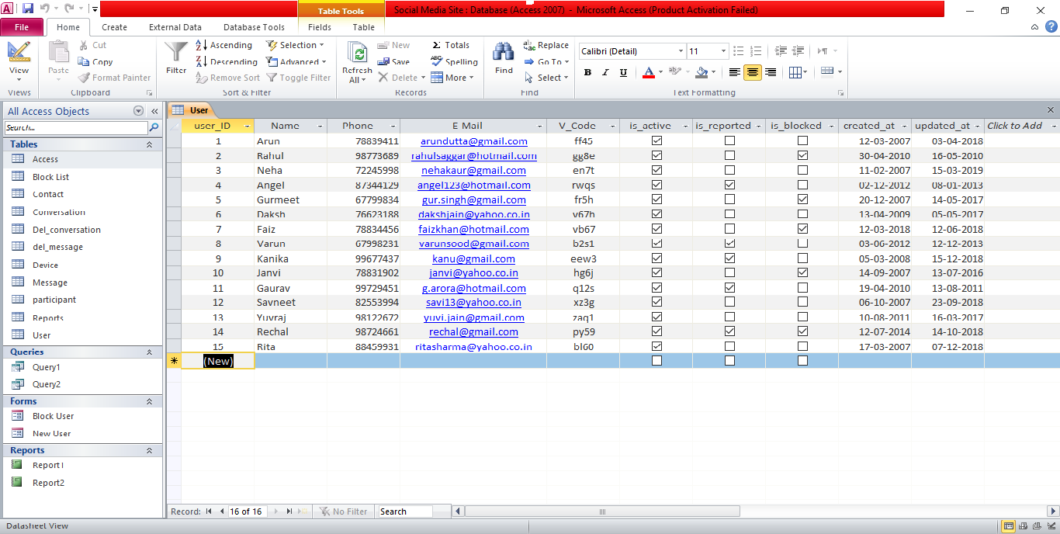

In this table, user_ID is the primary key since it is the unique attribute which determines all the other attributes of the table.

* **Contact Table:-**

This table contains the number of contacts/friends who are connected to a particular user through the Social Media Site. The attributes included in this table are: - user_ID, Name, E-Mail, Password, Number of Contacts.

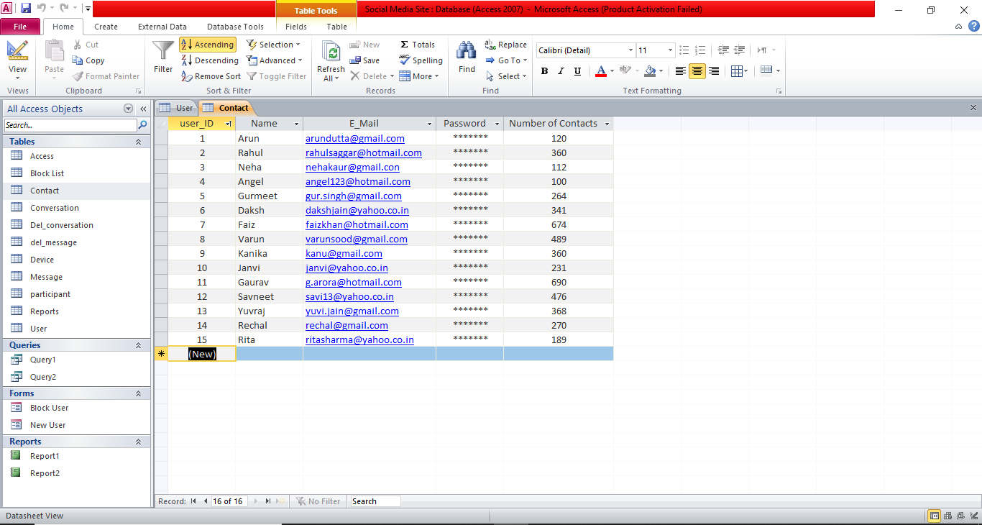

In this table, user_ID will act as the foreign key since it builds the relationship between the User and the Contact table.

* **Device Table:-**

This table contains the information about the device on which the user accesses his/her account. The attributes included in this table are: - user_ID, device_ID, device_type.

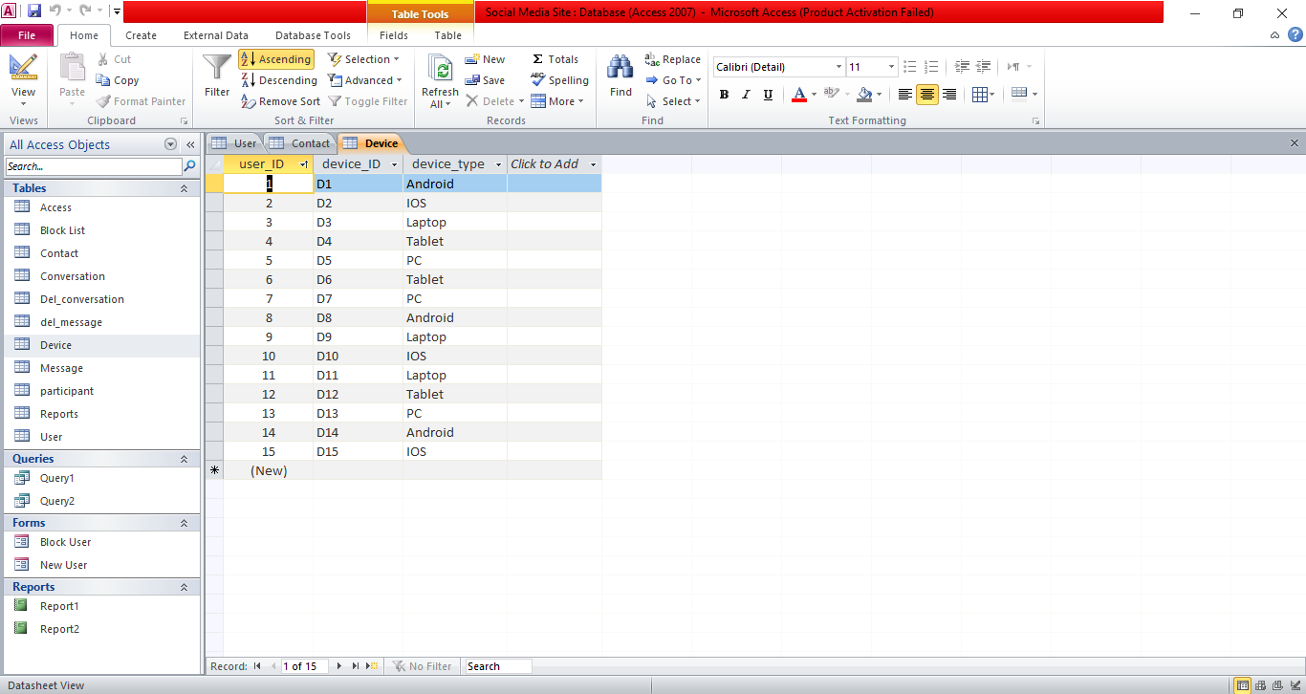

In this table, user_ID is the foreign key since it relates to the user in a way and helps in knowing about which device is being used by the user. Also, the device_ID used in this table is the primary key since it uniquely identifies the relation between the other attributes. The lookup wizard setting has been used for mentioning the types of devices that are used to operate a Social Media Site.

* **Access Table:-**

This table contains the information about the time for which the user accesses his account on the daily basis on a particular device. This table contains attributes such as: - user_ID, device_ID, date on which the account was created on a device, date on which the account was deleted from that device, time spent by the user daily.

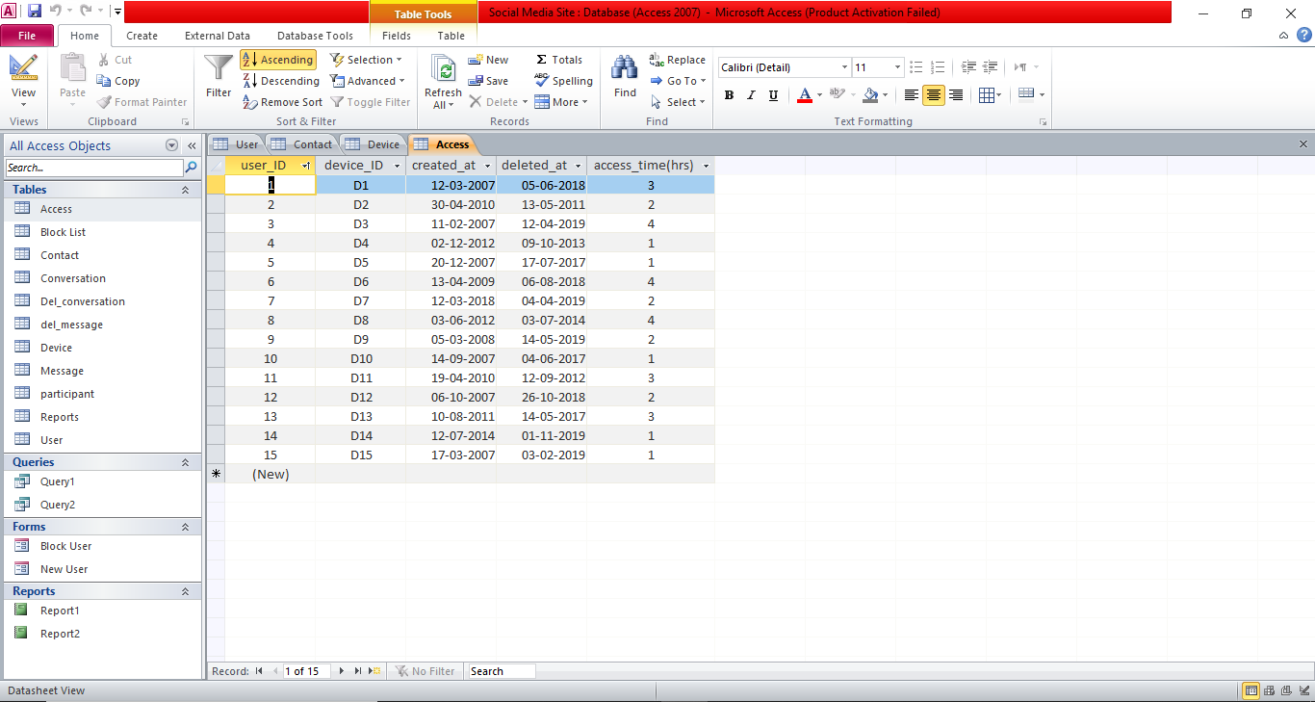

In this table, user_ID and device_ID are the foreign keys. Also, the access_time is shown with the help of lookup wizard setting with the options from 1 to 4.

* **Conversation Table:-**

This table contains the information about the basic conversation of the user who is willing to begin the conversation. This table includes the attributes such as:-user_ID, conversation_ID, title, creator_ID, channel_ID, date of creation of the conversation, date of updation of the conversation.

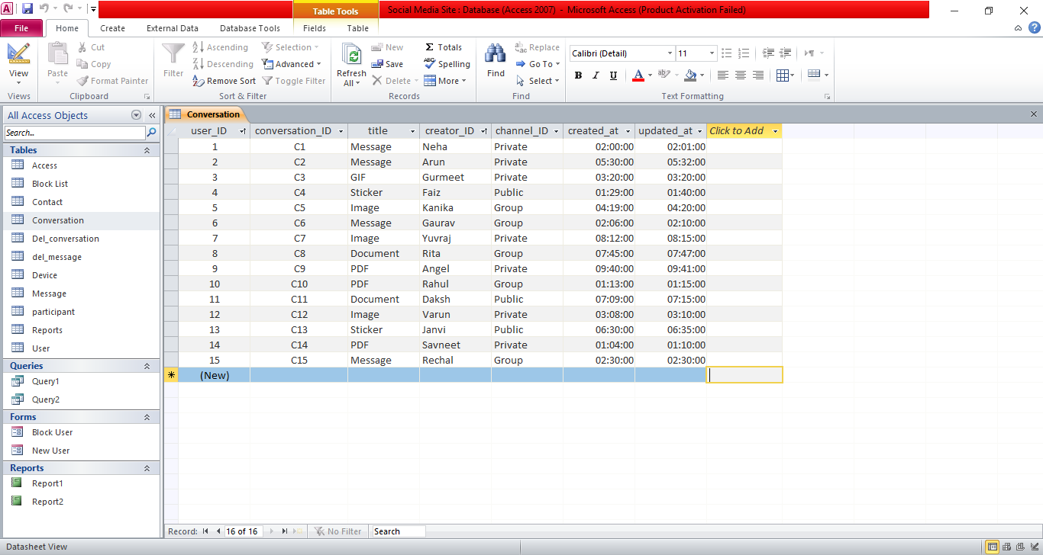

In this table, user_ID is the foreign key and conversation_ID is the primary key. Also, lookup wizard setting has been used in the classification of title of the conversation and describing the channel_ID of the conversation.

* **Deleted Conversation (Del_conversation):-**

This table includes the information about the conversation that has been deleted. This table includes the attributes such as: - ID, conversation_ID, and time at which the conversation was deleted.

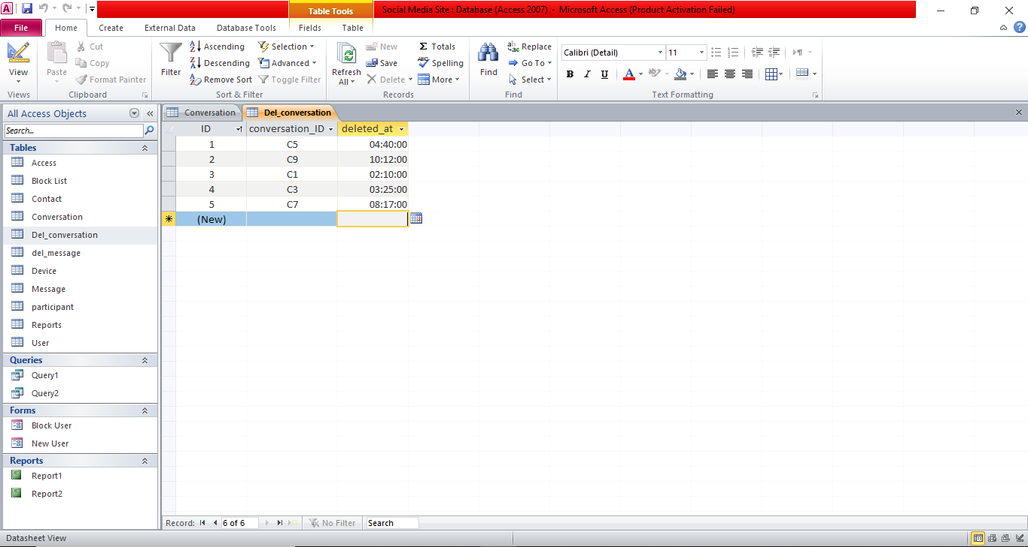

In this table, conversation_ID is the foreign key and ID is the primary key.

* **Participant Table:-**

This table contains the information about the participants who are taking part in the conversation. This table includes the following attributes: - user_ID, Participant_ID, conversation_ID.

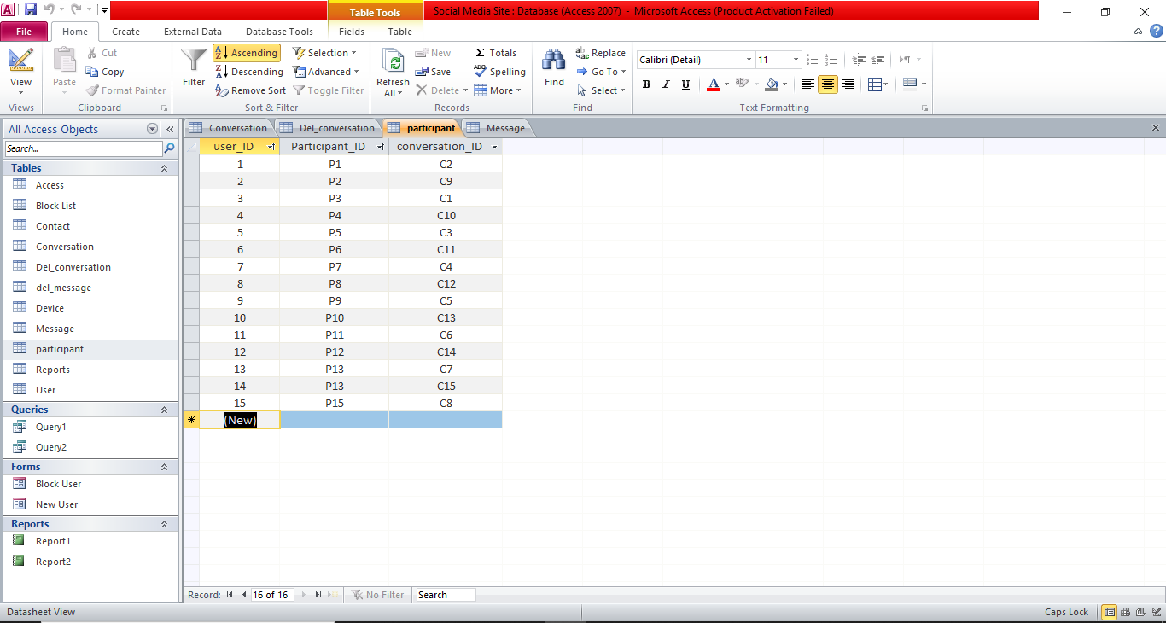

In this table, user_ID, Participant_ID and conversation_ID are the foreign keys and there is no primary key.

* **Message Table:-**

This table contains information about the message that is to be conversed and the participant that are involved in that conversation. This table includes the following attributes: - user_ID, Message_ID, conversation_ID, Sender_ID, Participant_ID, Message_type, date on which message was created.

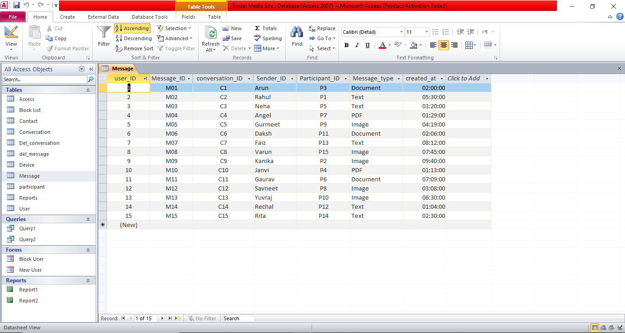

In this table, Message_ID is the primary key and user_ID, conversation_ID and Participant_ID are the foreign keys. Also, the lookup wizard setting has been used to classify the type of message that is being shared.

* **Deleted Message (del_message):-**

This table includes the information about the messages that have been deleted. This table includes the following attributes: - ID, Message_ID and the time when the message was deleted.

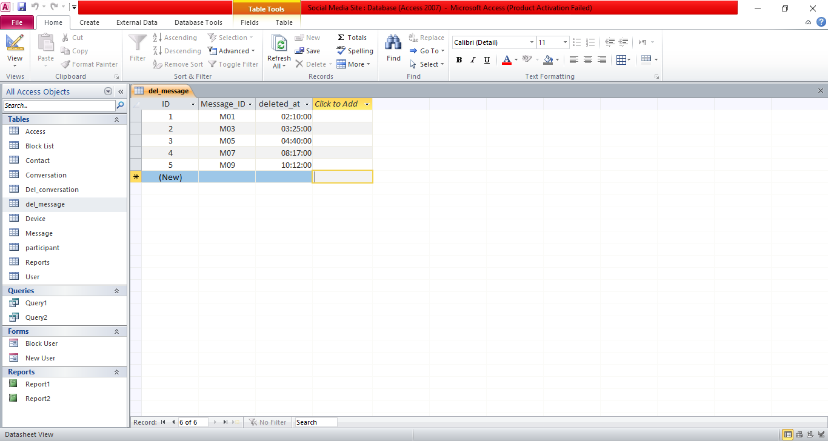

In this table, ID is the primary key and Message_ID is the foreign key.

* **Reports Table:-**

This table contains the information about the users whose ID has been reported on the Social Media Site. This table includes the attributes such as: - ID of the user reported, name of the ID reported, reason for reporting and time at which the ID was reported.

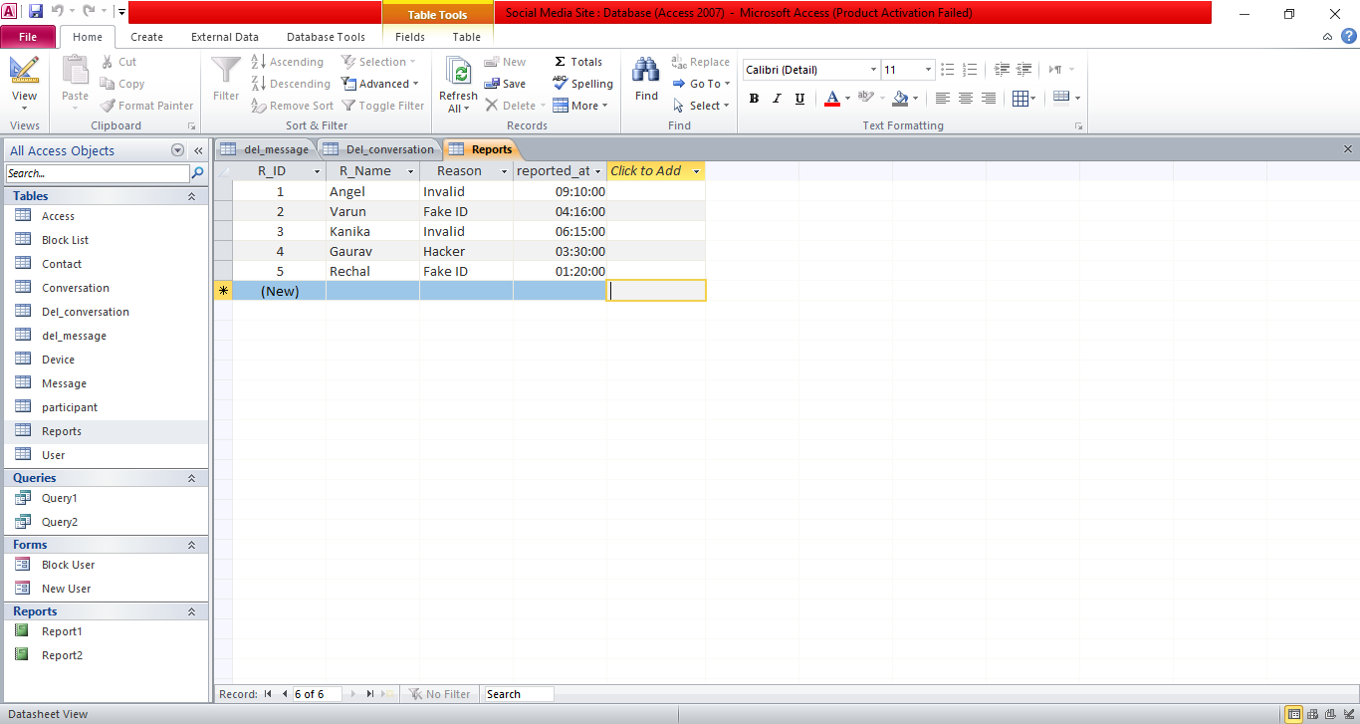

In this table, Report ID i.e., R_ID is the primary key and there is no foreign key.

* **Block List table:-**

This table contains the information about the users who have blocked various contacts from their contact/friends list. This table contains the following attributes: - user_ID, number of blocked contacts and time when they were blocked.

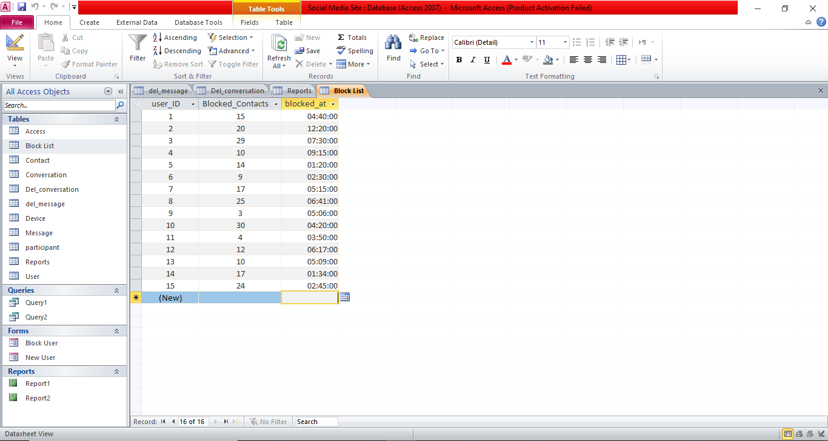

In this table, user_ID is the foreign key and there is no primary key.

**QUERY**

Queries select records from one or more tables in a database so they can be viewed, analyzed, and sorted on a common datasheet.

The Queries designed according to the SOCIAL MEDIA SITE DATABASE are as follows:-

**Query 1**- Find the details to the users who are neither blocked nor reported (i.e., Valid Users)?

For this the query has been designed in the manner that a criterion has been designed in the Query Design View that the users who are valid only those will be selected and the rest of the users will be eliminated.

The Design View of the query is as follows:-

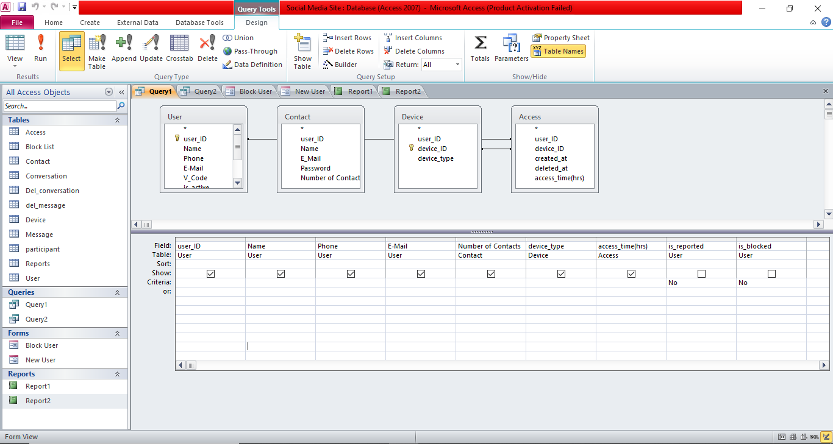

The output (Datasheet View) for the same is displayed as under:-

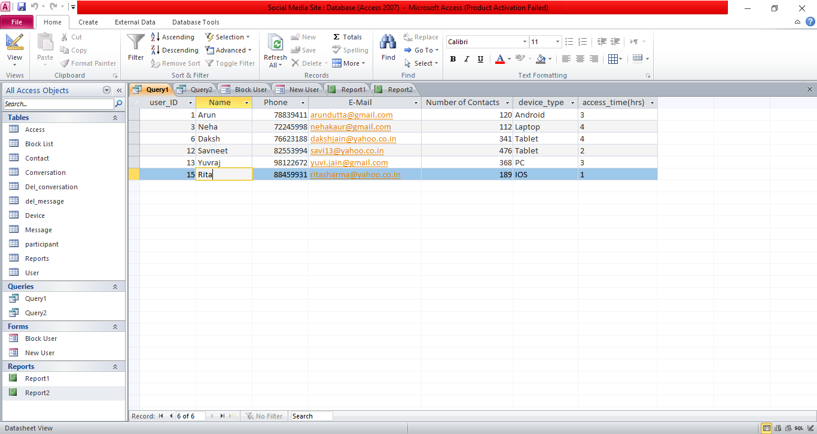

**Query 2**- Find the number of users who communicate through “Private Channel” and their account has been “Reported” (i.e., they are having their Fake ID’s)?

For this the query has been designed in the manner that a criteria has been designed in the Query Design View that the users who communicate through a “Private Channel” and their account has been “Reported” due to one or the other reason only those will be selected and the rest of the users will be eliminated.

The Design View of the query is as follows:-

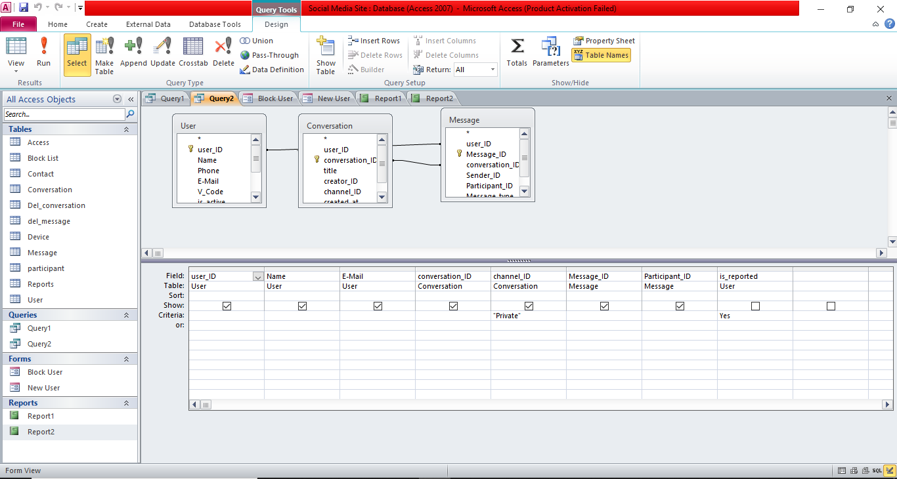

The output (Datasheet View) for the same is displayed as under:-

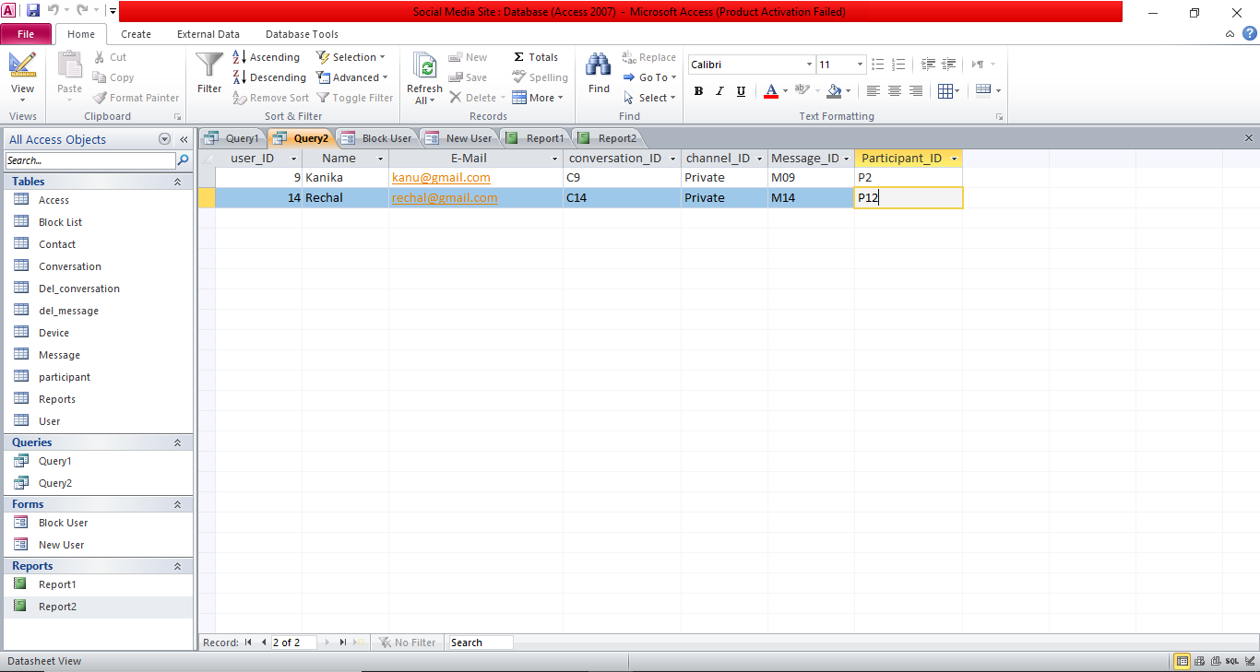

**REPORTS**

Reports are a means to view and analyze large amounts of data from underlying tables or queries. Report Wizard can be used to create a custom report xo as to meet the requirements.

The Reports designed according to the SOCIAL MEDIA SITE DATABASE are based on the Queries itself. These are as follows:-

**Report 1**- Find the details to the users who are neither blocked nor reported (i.e., Valid Users)?

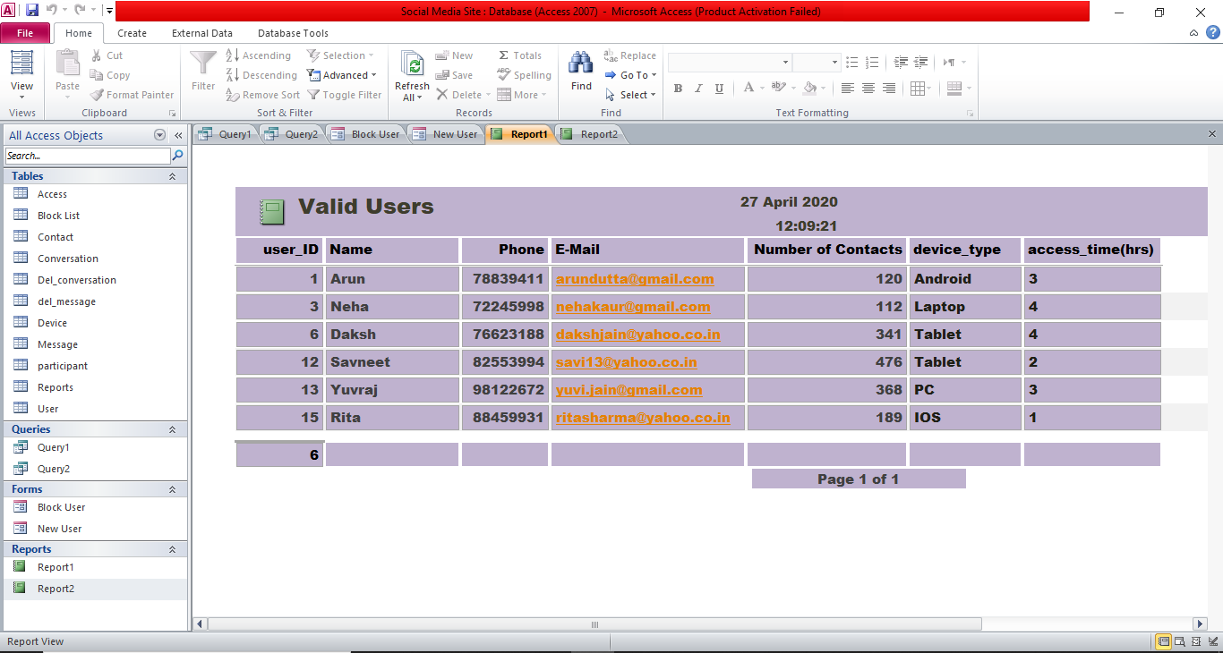

**Report 2**- Find the number of users who communicate through “Private Channel” and their account has been “Reported” (i.e., they are having their Fake ID’s)?

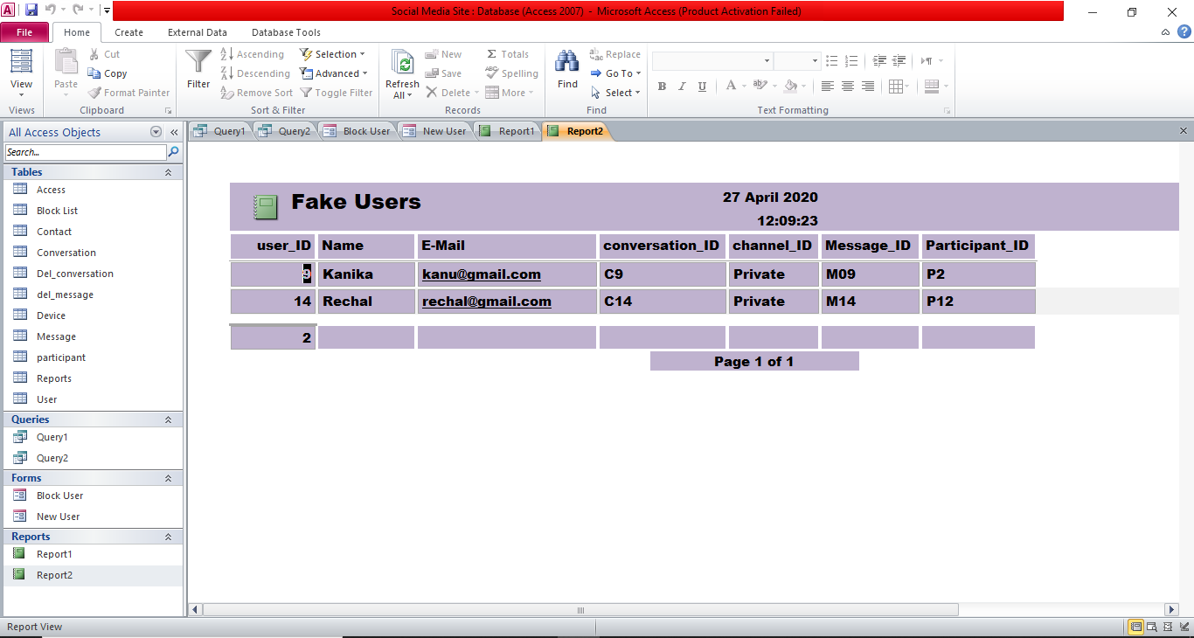

**FORMS**

Forms allow one to control the look and feel of the screen for the input of data and the reports generated.

The SOCIAL MEDIA SITE DATABASE can contain the following Forms for the convenience of the users:-

**Form 1**- When a new user wants to create his/her account:-

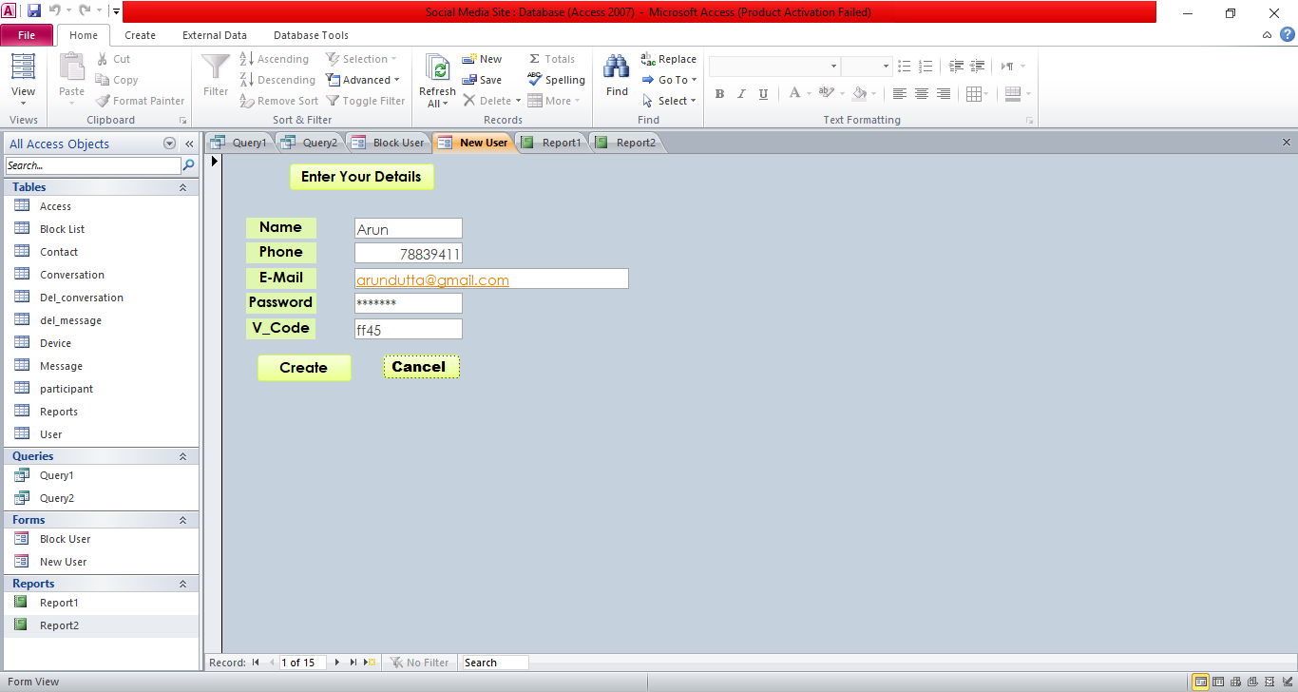

**Form 2**- When a user wants to block an account:-

